
Basic Quiz Application
Web Technologies

June 19, 2026
Malik Umar awan, khizar rehman, sheikh m taha ahmed
F2024376083, F2024376070, F2024376165



Student Name: | Malik Umar Awan, Khizar Rehman, Sheikh M Taha Ahmed
Student ID: | F2024376083, F2024376070, F2024376165
Program Title: | BS Artificial Intelligence Web Technologies
Assignment Title: | Web Technologies Project: Basic Quiz Application
Date of Submission: | 19/06/2026
Submitted to: | Professor. Shehan Latif

Project Report: Basic Quiz Application

Contents
Introduction: 2
Objective: 2
Tools / Technologies Used: 2
Features of the Project: 3
Screenshots / Output: 4
Main (First Question) Display: 4
Timer Warning: 4
Correct Answer Feedback: 5
Wrong Answer Feedback: 6
Results Summary: 7
Review Answers Section: 8
Mobile View: 9
Algorithm / Flowchart: 10
Code Explanation: 12
HTML Structure: 12
CSS Styling: 13
JavaScript Logic: 13
Challenges Faced: 13
Conclusion: 14
References: 14

Introduction:
The Basic Quiz Application is a web-based interactive quiz system designed to test users' knowledge on web technologies. It presents 10 multiple-choice questions, tracks the user's score, provides immediate feedback, and displays a detailed summary at the end. The application is built using HTML, CSS, and JavaScript, and includes advanced features such as a timer, progress bar, shuffled questions, and a review section.
This project was developed as part of the Web Technologies course (IT-291) to demonstrate practical skills in front-end web development.

Objective:
The main objectives of this project are:
- To create an interactive quiz application with 10 multiple-choice questions.
- To implement a scoring system that tracks correct answers in real-time.
- To provide immediate visual feedback (green for correct, red for wrong).
- To include a 30-second timer for each question.
- To shuffle both questions and options for a unique experience each time.
- To display a results summary with score, percentage, and performance message.
- To allow users to review all their answers with correct answers shown.
- To save the user's highest score using browser local Storage.
- To make the application responsive for desktop and mobile devices.

Tools / Technologies Used:
Technology | Purpose
HTML5 | Structure and content of the web page.
CSS3 | Styling, animations, and responsive design.
JavaScript (ES6) | Quiz logic, DOM manipulation, event handling.
VS Code | Code editor.
GitHub | Version control and hosting.
GitHub Pages | Live hosting of the website.
Live Server | Local development preview.

Features of the Project:
Core Features:
- 10 Multiple-Choice Questions: Questions on HTML, CSS, and JavaScript.
- Shuffle Questions: Questions appear in random order.
- Shuffle Options: Answer options appear in random order.
- 30-Second Timer: Each question has a time limit. Blinks red when reaches 5 seconds.
- Auto-Fail on Timeout: If time runs out, the question is marked wrong.
- Progress Bar: Visual indicator of quiz completion.
- Real-Time Score Tracking: Score updates instantly.
- Correct Feedback: Correct answers turn green.
- Wrong Feedback: Wrong answers turn red, correct answer is shown.
- Results Summary: Shows final score, percentage, and performance message.
- Performance Message: Personalized message based on score.
- High Score Tracking: Best score saved in browser local Storage.
- Review Answers: Shows all questions with user answers and correct answers.
- Restart Quiz: Reset and play again.
- Responsive Design: Works on desktop, tablet, and mobile.
- Professional Styling: Gradient background, shadows, rounded corners.

Screenshots / Output:

Main (First Question) Display:
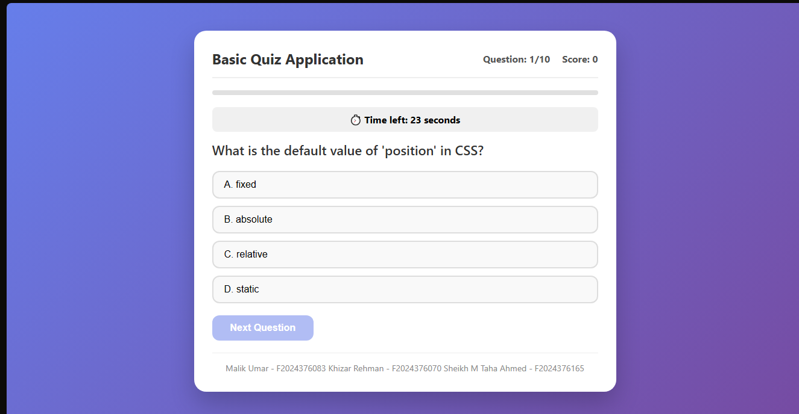

Timer Warning:
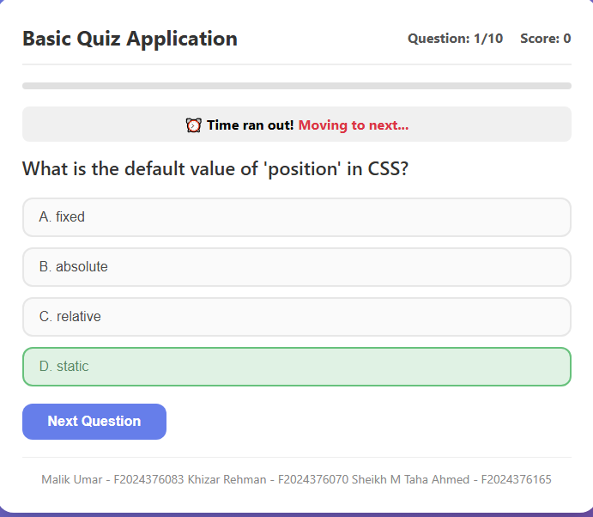

Correct Answer Feedback:
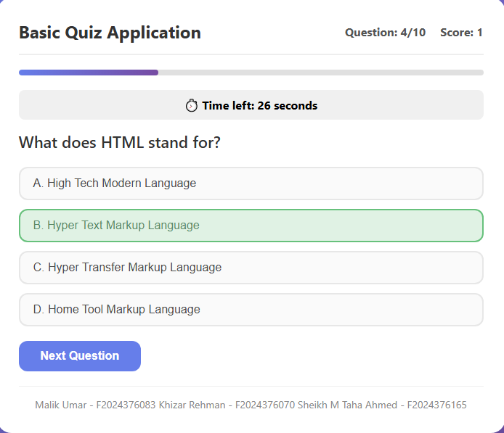

Wrong Answer Feedback:
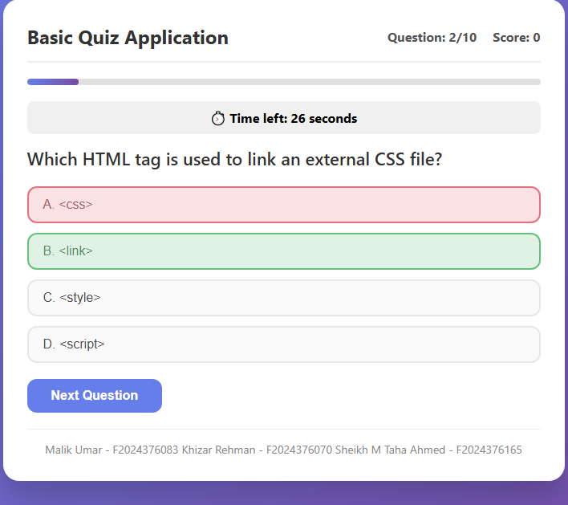

Results Summary:
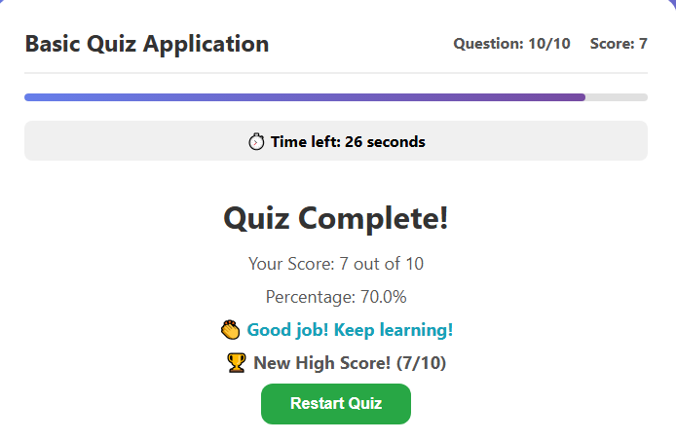

Review Answers Section:
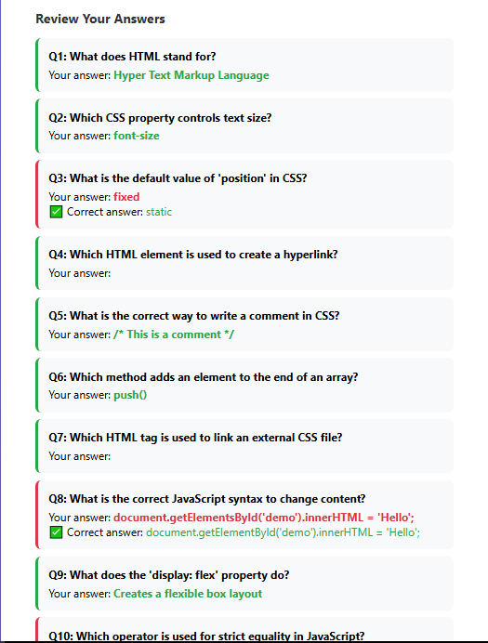

Mobile View:
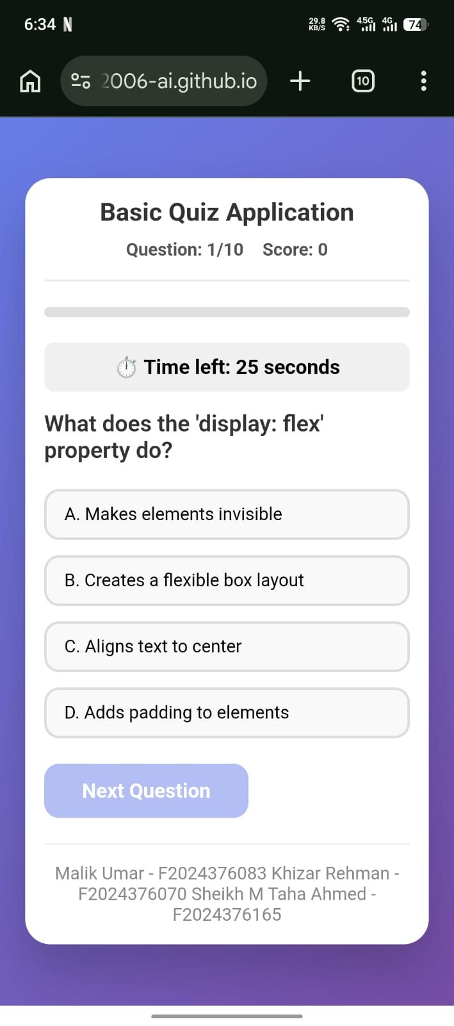

Algorithm / Flowchart:
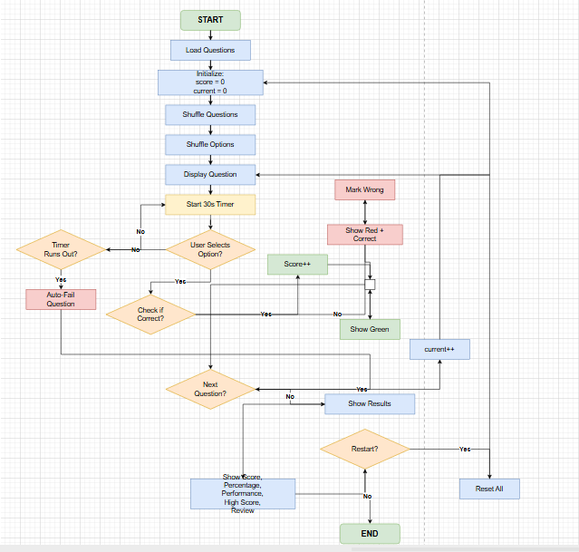

1. Start
- User opens the quiz application.
2. Load Questions
- Load 10 questions from the questions array.
3. Initialize Variables
- score = 0
- current Question = 0
- answered = false
- quiz Completed = false
4. Shuffle Questions
- Randomize the order of questions.
5. Shuffle Options
- Randomize the order of options for each question.
6. Display Question
- Show the question, 4 options, question number, and progress bar.
7. Start Timer
- Start a 30-second countdown.
8. Wait for User Action
If User Selects an Option:
- Correct: Highlight GREEN → Increase score.
- Wrong: Highlight RED → Show correct answer in GREEN.
- Store user's answer.
- Stop timer.
- Enable "Next" button.
If Timer Runs Out:
- Auto-fail the question.
- Show correct answer.
- Enable "Next" button.
9. Move to Next Question
- Click "Next" button.
- If questions remain → Go to Step 6.
- If all questions done → Go to Step 10.
10. Show Results
- Display:
  - Final Score
  - Percentage
  - Performance Message (Excellent/Good/Practice/Better Luck)
11. Show High Score
- Check local Storage.
- Save new high score if higher.
- Display best score.
12. Show Review
- Display all questions.
- Show user's answer and correct answer for each.
- Highlight correct (green) and wrong (red).
13. Restart or End
If User Clicks "Restart":
- Reset all variables → Go to Step 3.
If User Closes Page:
- End.

Code Explanation:

HTML Structure:
The HTML file contains the main structure of the quiz application:
- Container: The main white card that holds all content.
- Header: Shows the quiz title, question number, and score.
- Progress Bar: Visual indicator of quiz progress.
- Timer: Shows remaining time for the current question.
- Quiz Section: Displays the question and options.
- Results Section: Shows score, percentage, performance message, high score, and review answers.
- Footer: Displays student name and ID.

CSS Styling:
The CSS file provides the visual design:
- Gradient Background: Purple to blue gradient for the page.
- White Card: Clean white container with shadow.
- Option Buttons: Styled with hover effects and feedback colors.
- Correct Answers: Green background (#d4edda).
- Wrong Answers: Red background (#f8d7da).
- Timer Warning: Red blinking animation for last 5 seconds.
- Responsive Design: Media queries for mobile devices.

JavaScript Logic:
The JavaScript file contains all the quiz logic:
- Question Bank: Array of 10 question objects.
- Shuffle Function: Randomizes array order.
- Load Question: Displays the current question with shuffled options.
- Timer: Counts down from 30 seconds, auto-fails on timeout.
- Option Selection: Handles user selection, checks correctness, updates score.
- Next Button: Moves to the next question or shows results.
- Results Display: Shows score, percentage, performance message, high score.
- Review Answers: Displays all questions with user answers and correct answers.
- Restart: Resets all state variables and restarts the quiz.

Challenges Faced:
Challenge | Solution
Timer not moving | Fixed by correctly referencing the timer element using document.getElementById('timer')
Results not displaying | Fixed the show Results () function to properly hide quiz and show results section.
Restart not working properly | Reset all state variables including quiz Completed, user Answers, and questions Copy.
Options not shuffling | Created a shuffled copy of option indices and displayed them in random order.
High score not saving | Used local Storage to persist the best score across sessions.

Conclusion:
The Basic Quiz Application successfully demonstrates the practical use of HTML, CSS, and JavaScript to build an interactive web application. All features work correctly, including the timer, shuffle, progress bar, score tracking, results summary, review answers, and high score storage.
Through this project, I learned:
- How to manipulate the DOM using JavaScript.
- How to handle user events (click, timer).
- How to manage application state.
- How to style a responsive web page.
- How to use local Storage for data persistence.
- How to deploy a website using GitHub Pages.
This project has strengthened my understanding of front-end web development and prepared me for projects that are more complex in the future.

References:
- MDN Web Docs – JavaScript documentation
https://developer.mozilla.org/en-US/docs/Web/JavaScript
- W3Schools – HTML, CSS, and JavaScript tutorials
https://www.w3schools.com/
- GitHub Pages – Hosting documentation
https://pages.github.com/
- VS Code – Code editor
https://code.visualstudio.com/
- Draw.io – Flowchart creation
https://app.diagrams.net/

